Tema 17

Bug report 1:

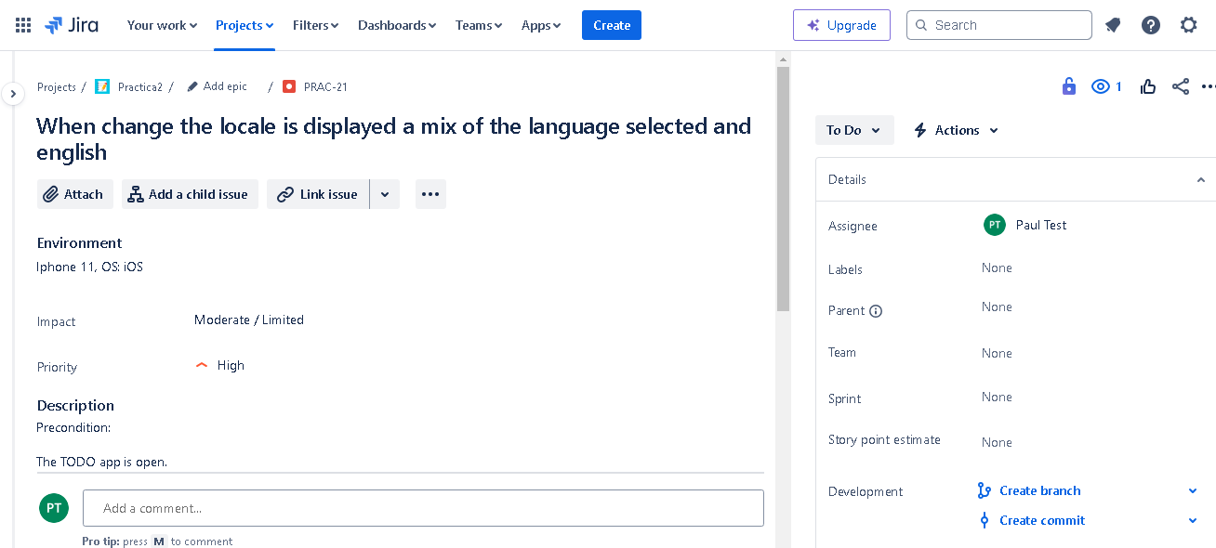

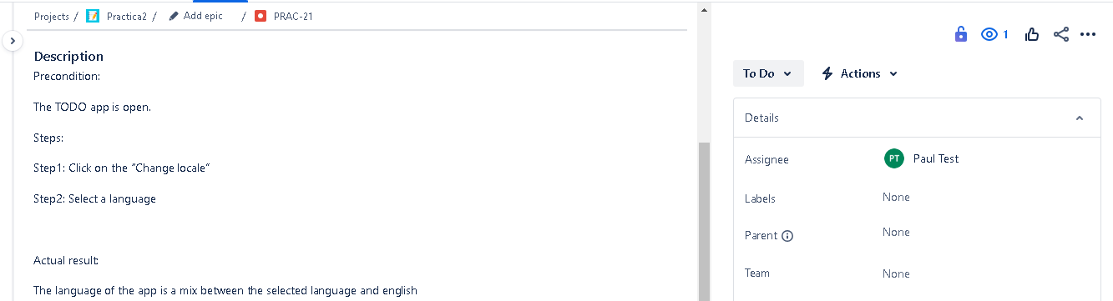

Bug report 2:

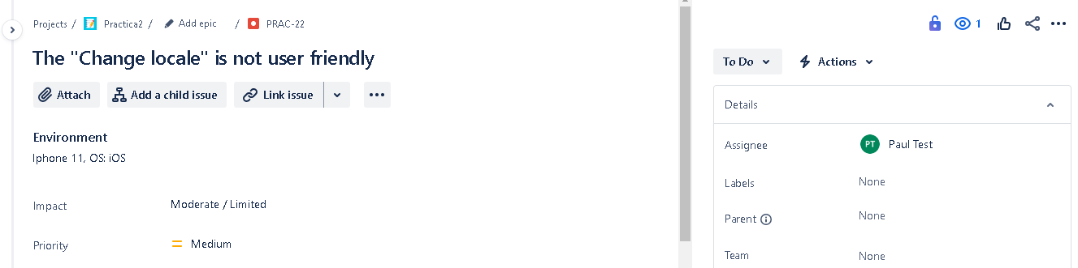

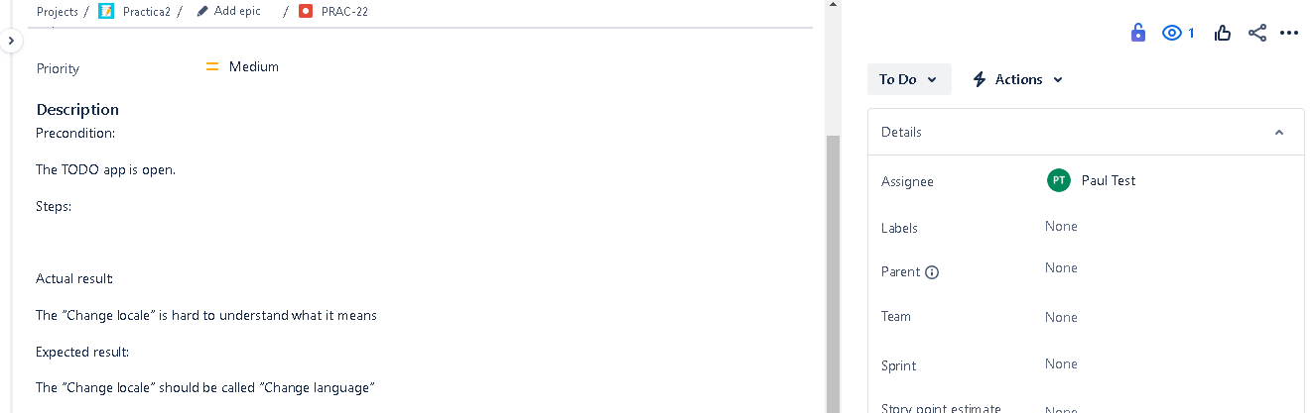

Bug report 3:

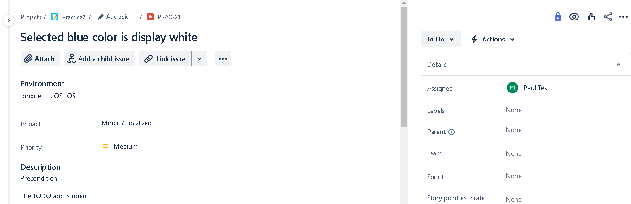

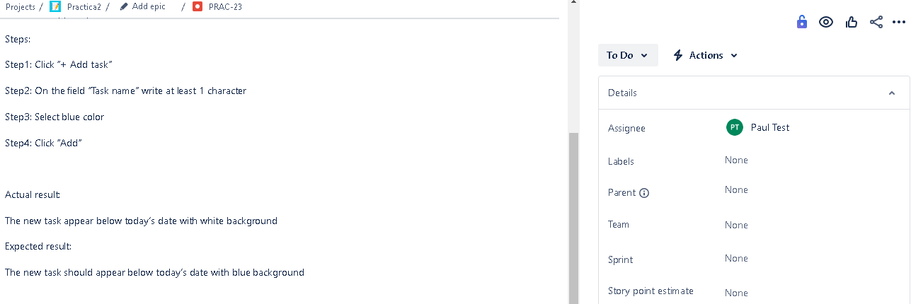

Bug report 4:

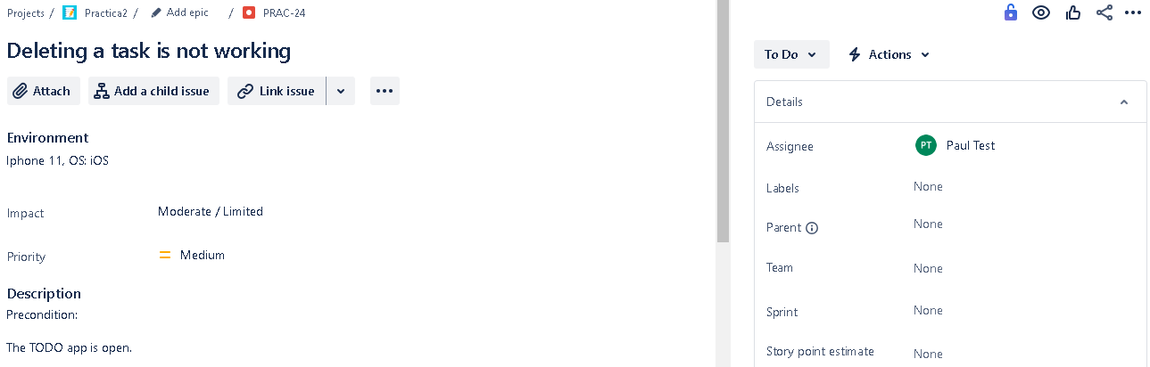

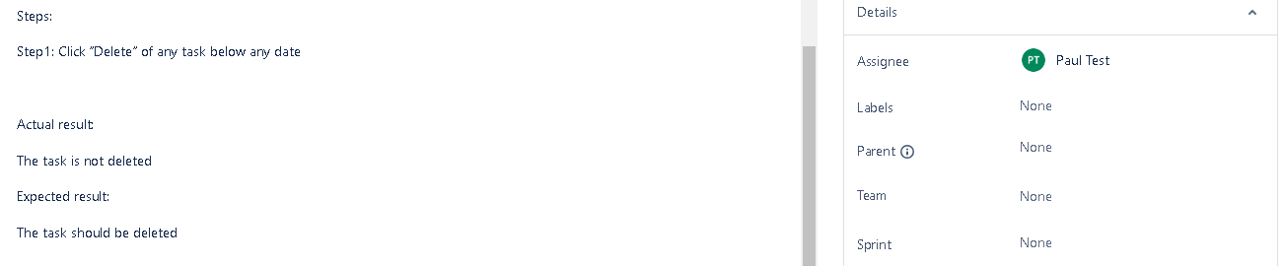

Bug report 5:

